LINUX TASK DOCUMENT
- Create user with name Techie and provide sudo access to user.
First, a new user named Techie was created using the adduser command.
Password is created for user techie.
Then, the user was added to the sudo group
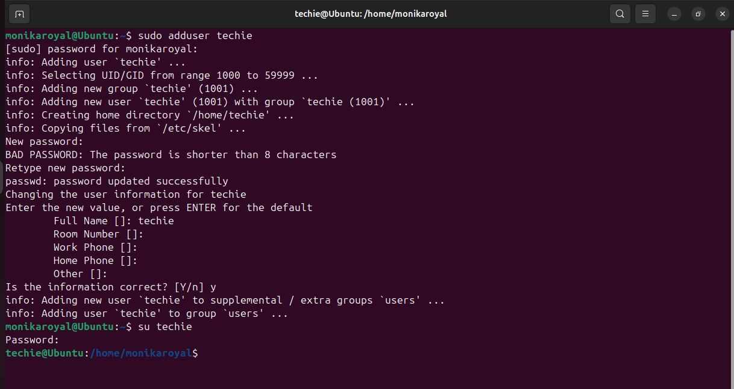

2.) Navigate to the home directory.
The cd ~ command was used to access the home directory.
The pwd command was used to confirm the current working directory.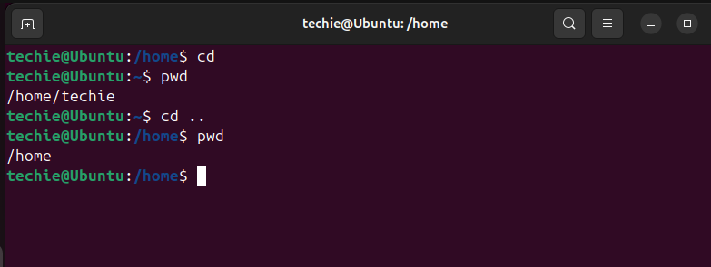

3. Create a new directory.
The mkdir command was used to create a new directory called monika.
Using the ls command to list files, the directory creation was verified.


4.List the contents of a directory.
The contents of the directory are displayed using ll
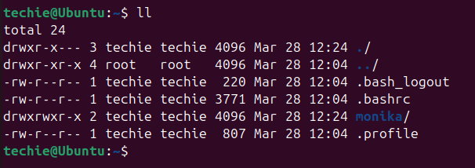

5) Change the current directory
The current directory was changed by using the cd command.
The location was verified again using the pwd command.
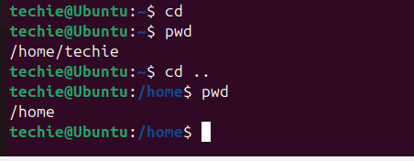

6) Create a new empty file.
I have created a new empty file usin touch
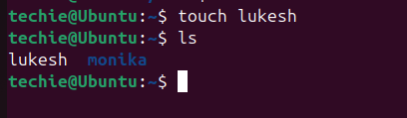

7) View the contents of a file.
By using cat we can see the contents of the file
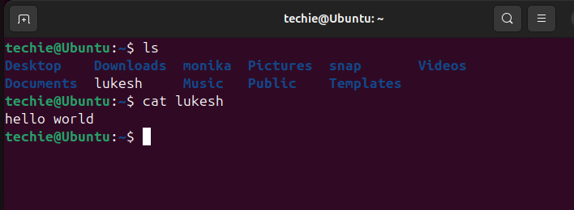

8)Copy a file to another location.
The file was copied to another file using the cp command, creating a duplicate file.
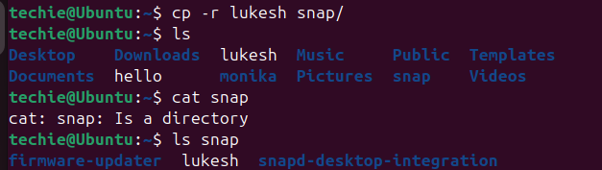

9) Move a file to another location.
The file was moved from one directory to another using the mv command.
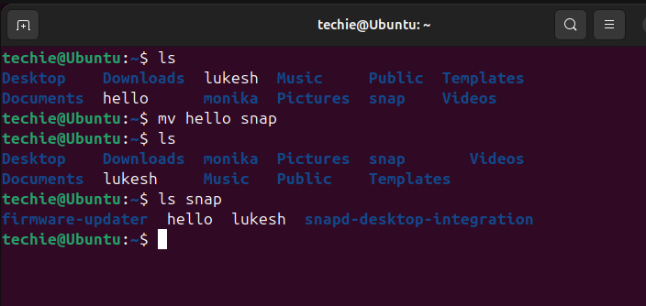

10) Rename a file.
The file was renamed using the mv command by specifying a new filename.
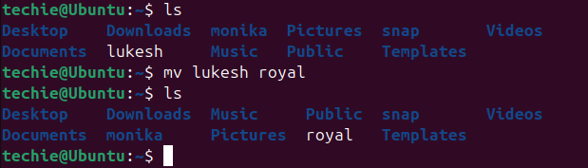

11) Delete a file.
The file was deleted using the rm -rf command.
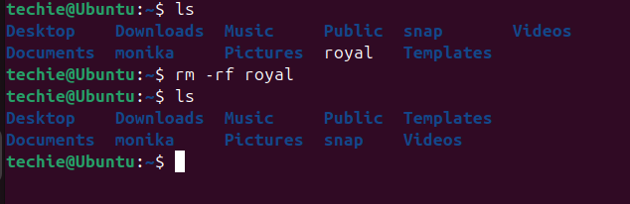

12) Grant or revoke permissions on a file or directory.
File permissions were changed using the chmod command.
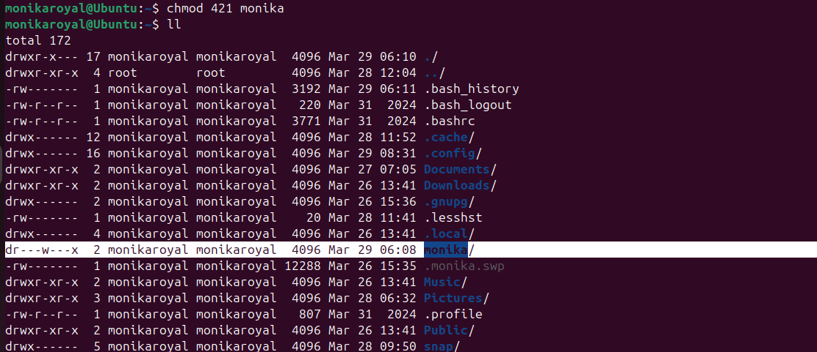
13.) View the current date and time.
date – To view current date and time.
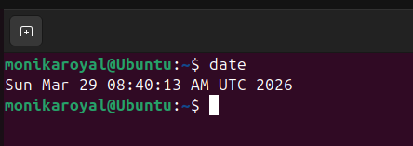
14) Check the system uptime.
System uptime was checked using the uptime command.
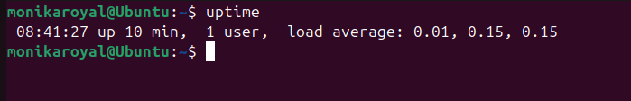

15) View the running processes.
Running processes were viewed using the ps aux command.
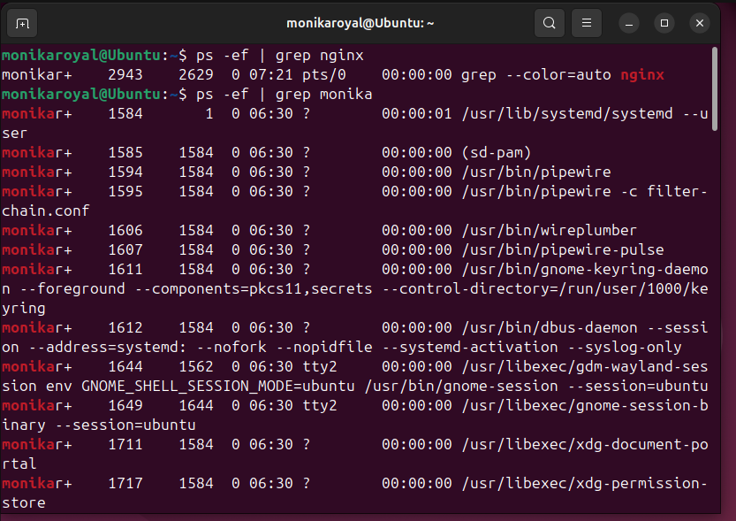

16) Kill a running process.
A process was terminated using the kill -9 command.

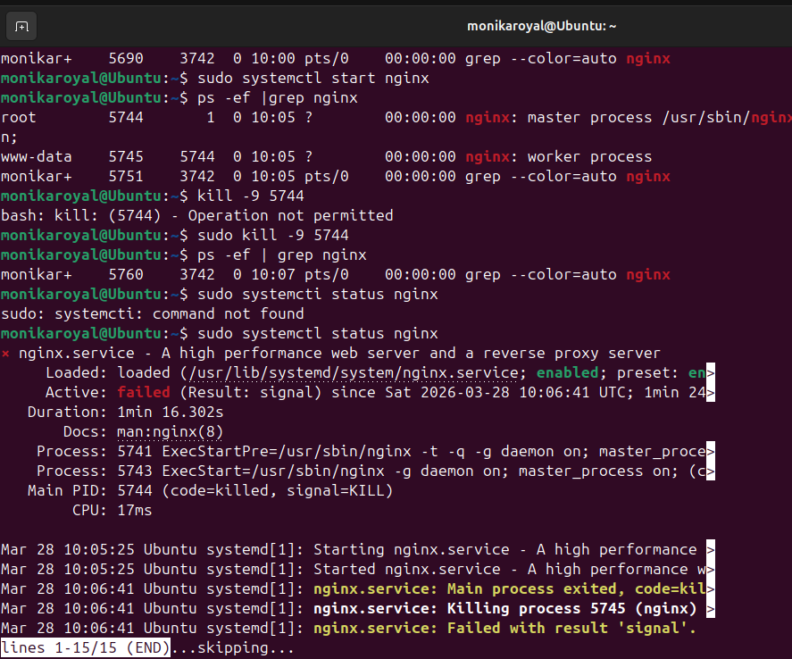

17) Install a package using the package manager (e.g., apt or yum).
A package was installed using the package manager (apt install).
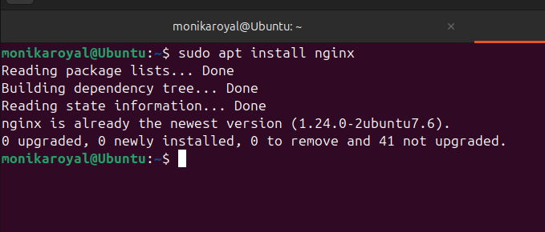

18) Update the system packages.
System packages were updated using apt update.
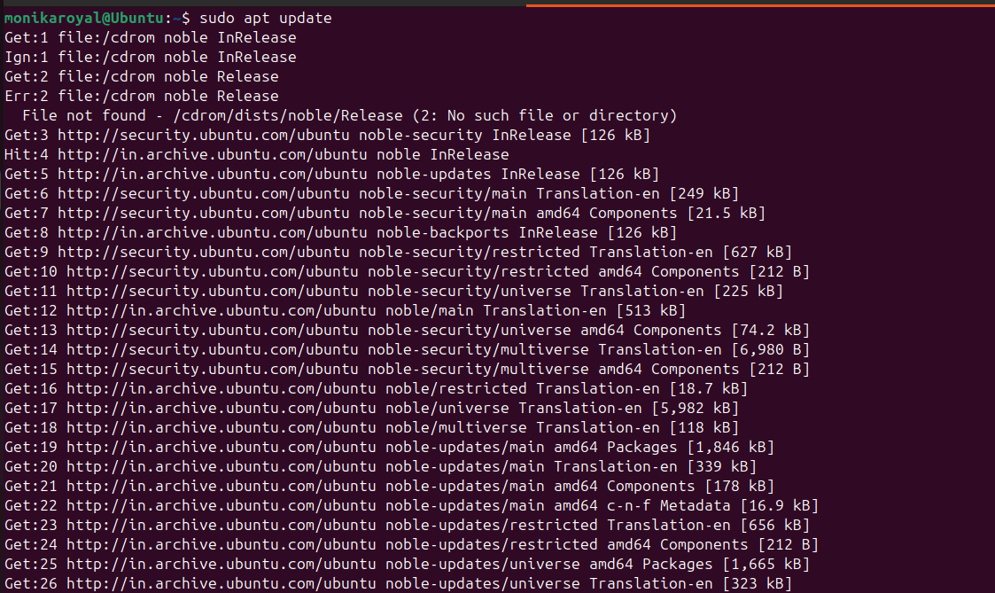

19) Create a symbolic link.
A symbolic link was created using the ln -s command.
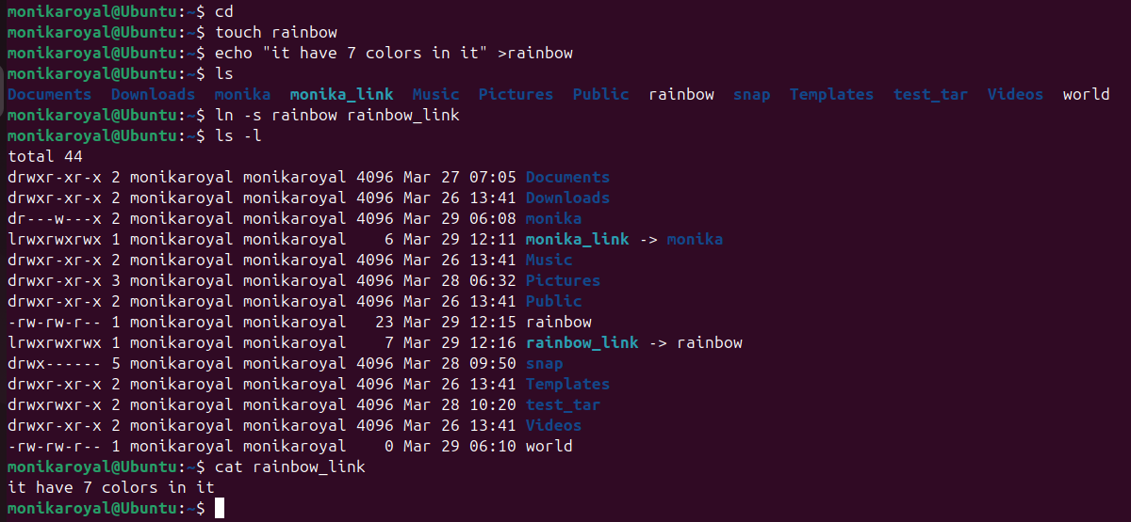
20) Search for files using the find command.
Files were searched using the find command.
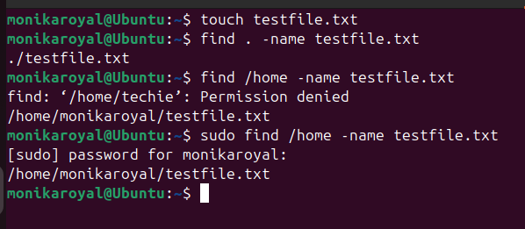

21) Compress and decompress files using tar.
Files were compressed and decompressed using the tar command.
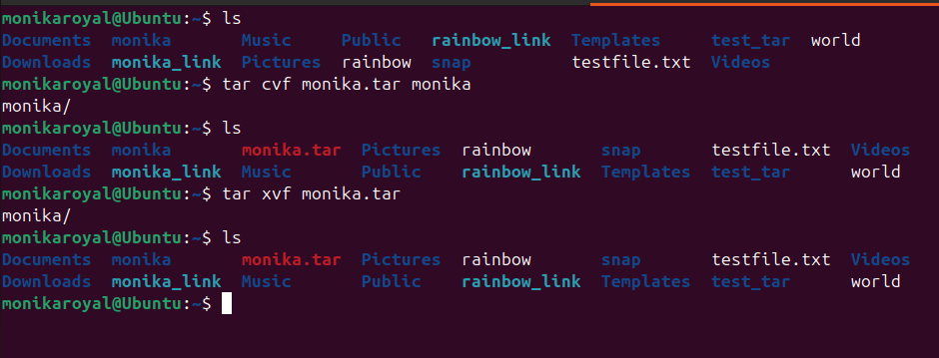

22) Monitor system resources with top or htop.
System resources were monitored using top or htop.
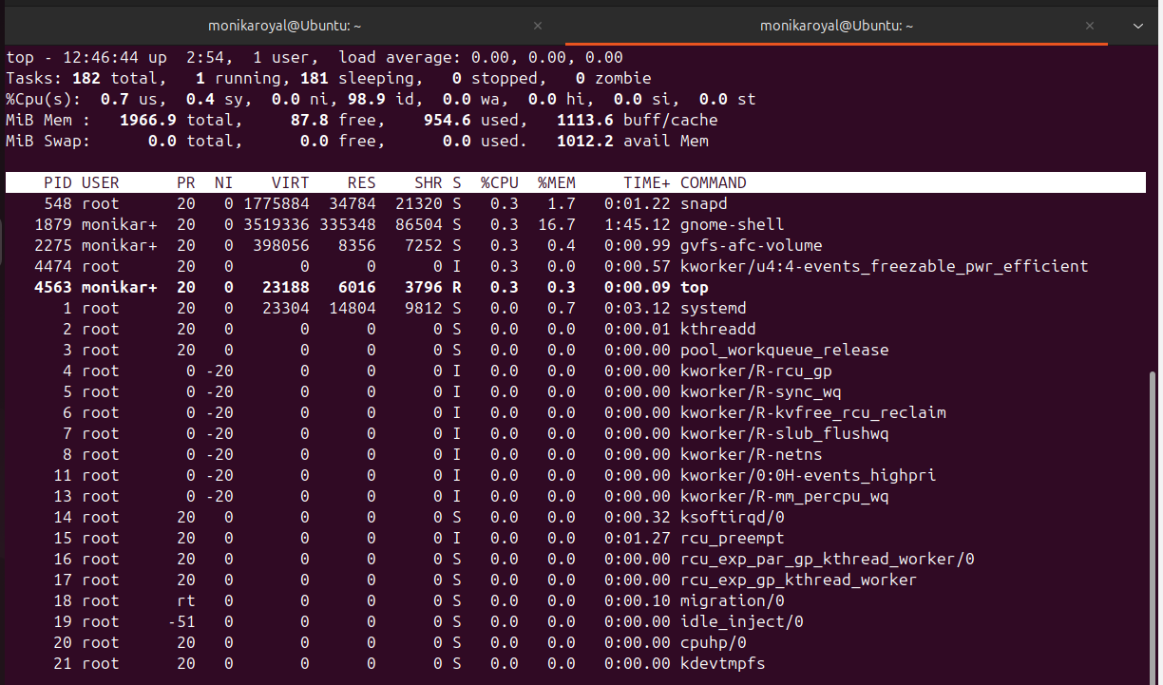
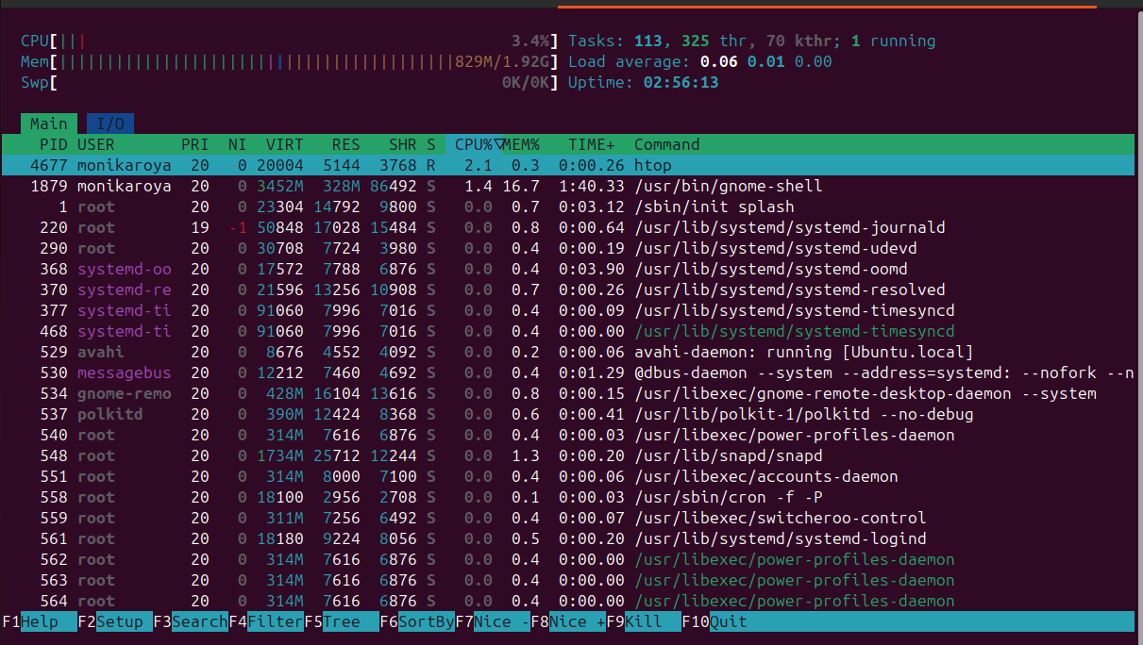
23) Create and manage user groups.
User groups were created and managed using groupadd, usermod, and gpasswd.
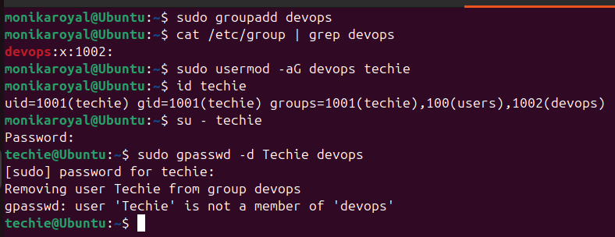

24) Set up SSH password less authentication.
SSH password-less authentication was configured using ssh-keygen and ssh-copy-id.
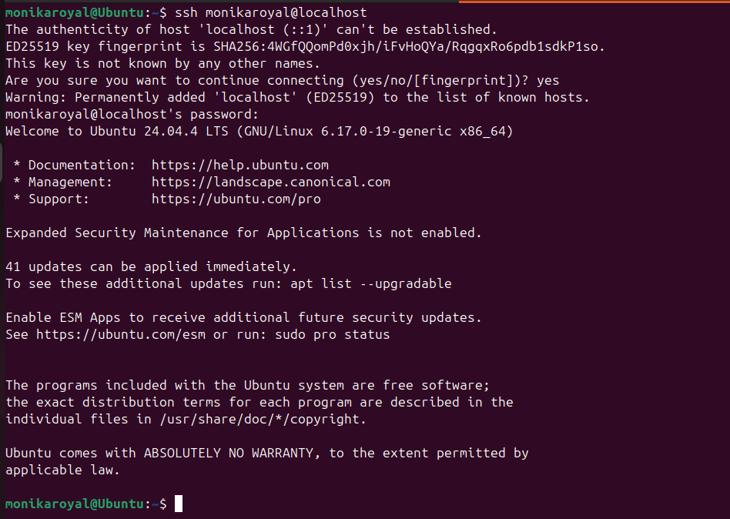

25) Monitor log files using tail or grep.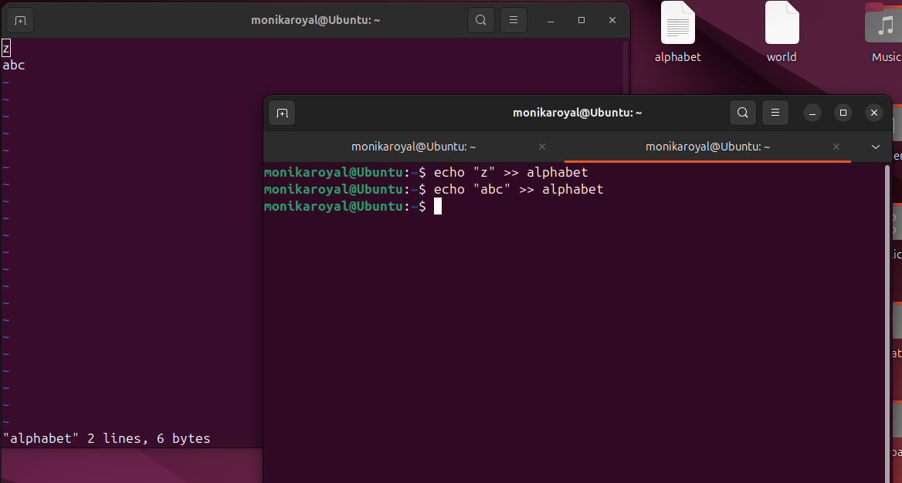
26) Set up a web server (e.g., Apache or Nginx).
A web server was set up using Nginx and managed with systemctl. 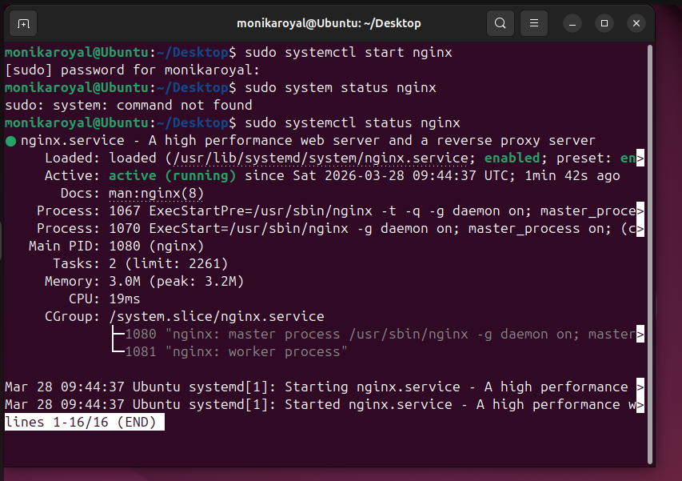
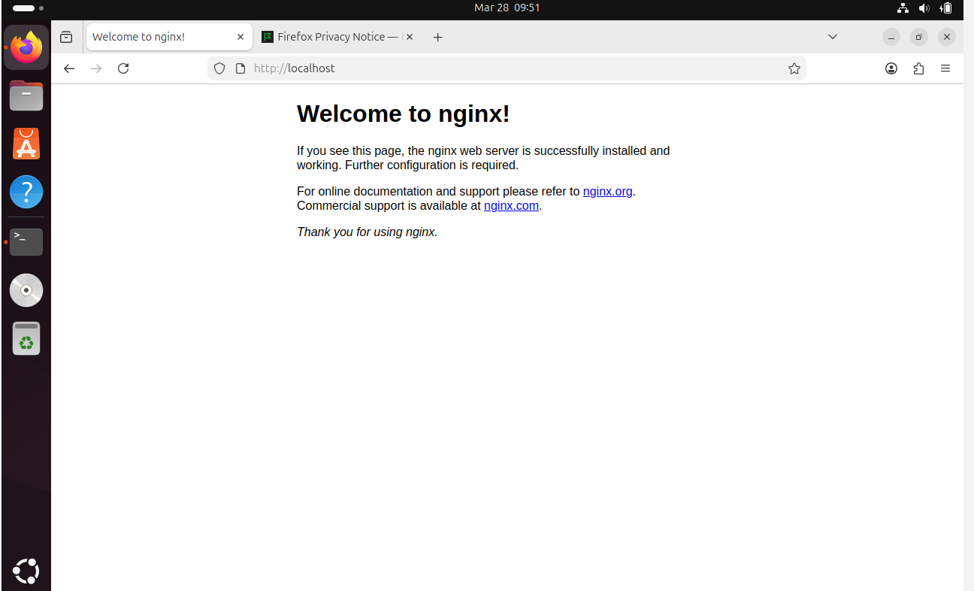

27) Configure and secure a MySQL Database.
A MySQL database was installed, secured, and configured with users and privileges.
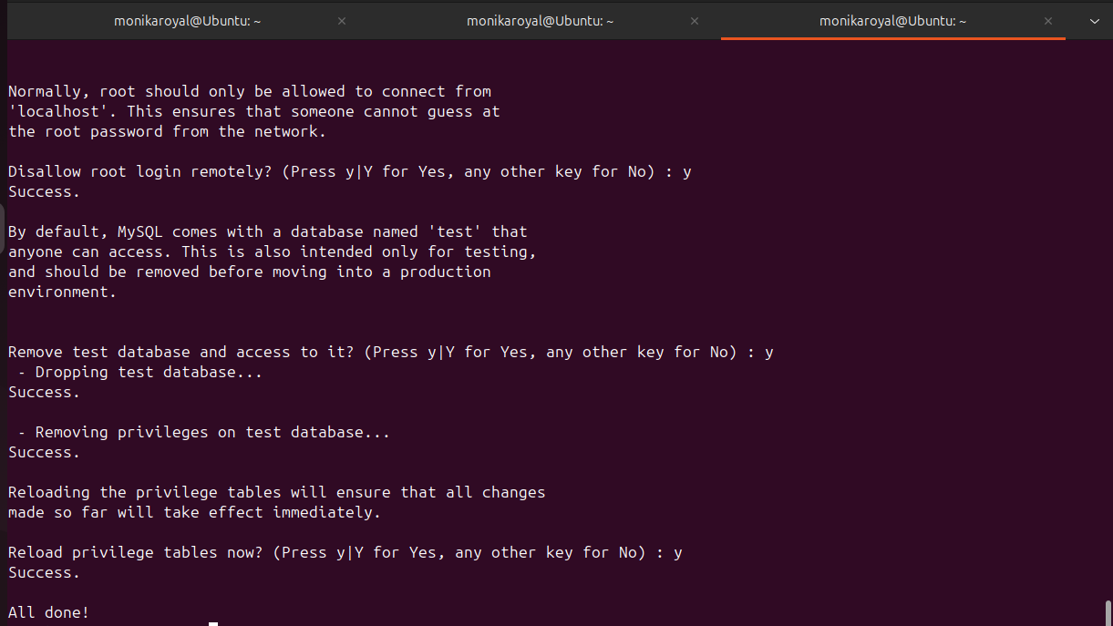
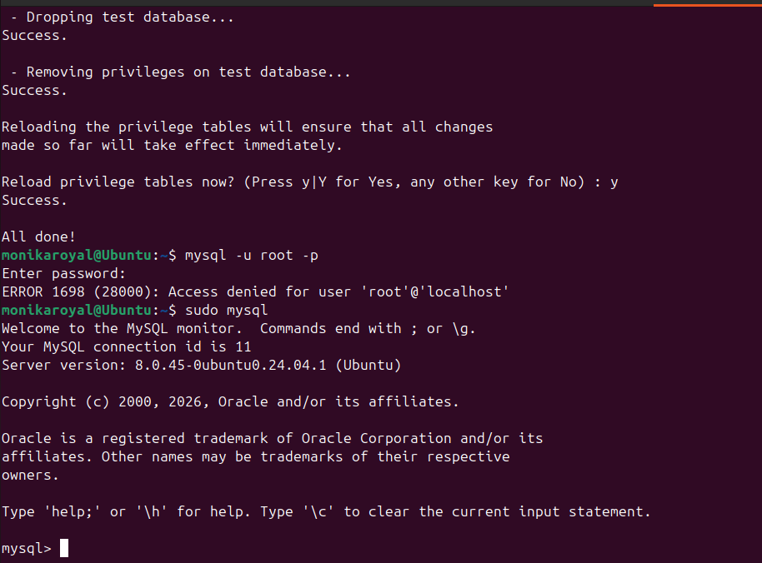

28) Set up a Application Server (e.g.,Apache)
An application server was set up using Apache Tomcat
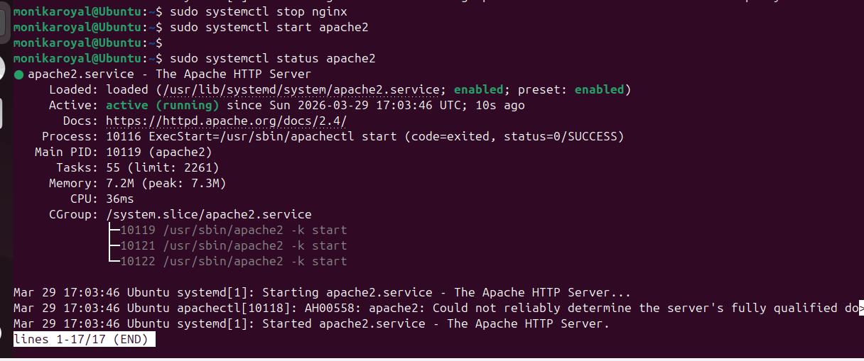
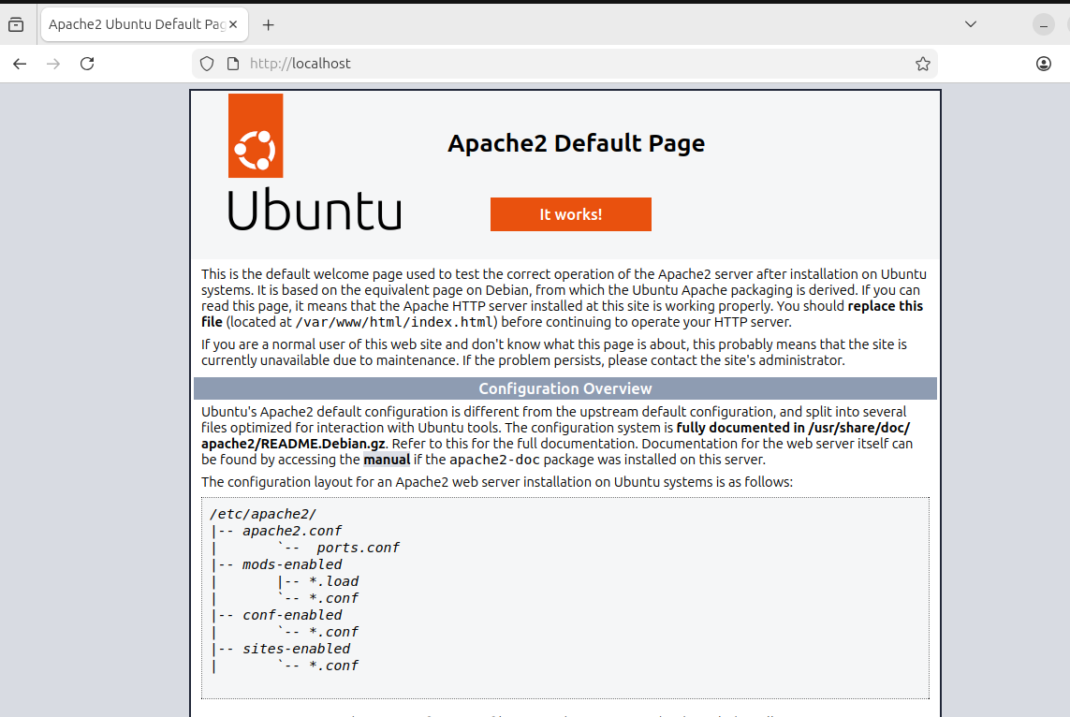
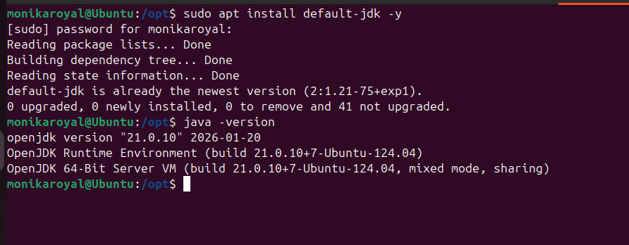

29) create a service file for Apache Tomcat.
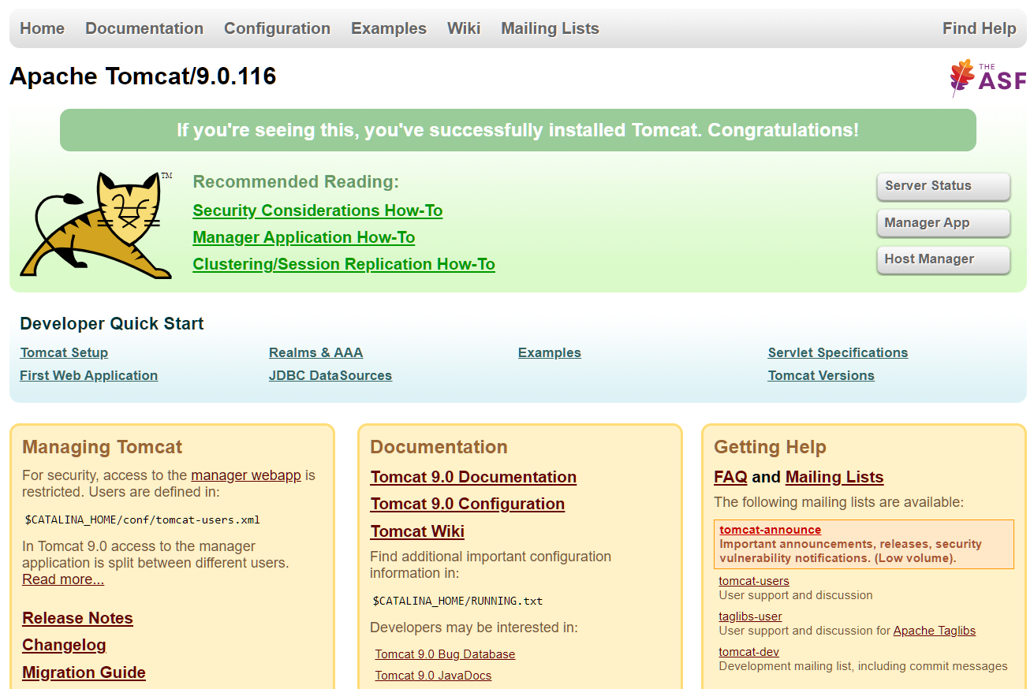
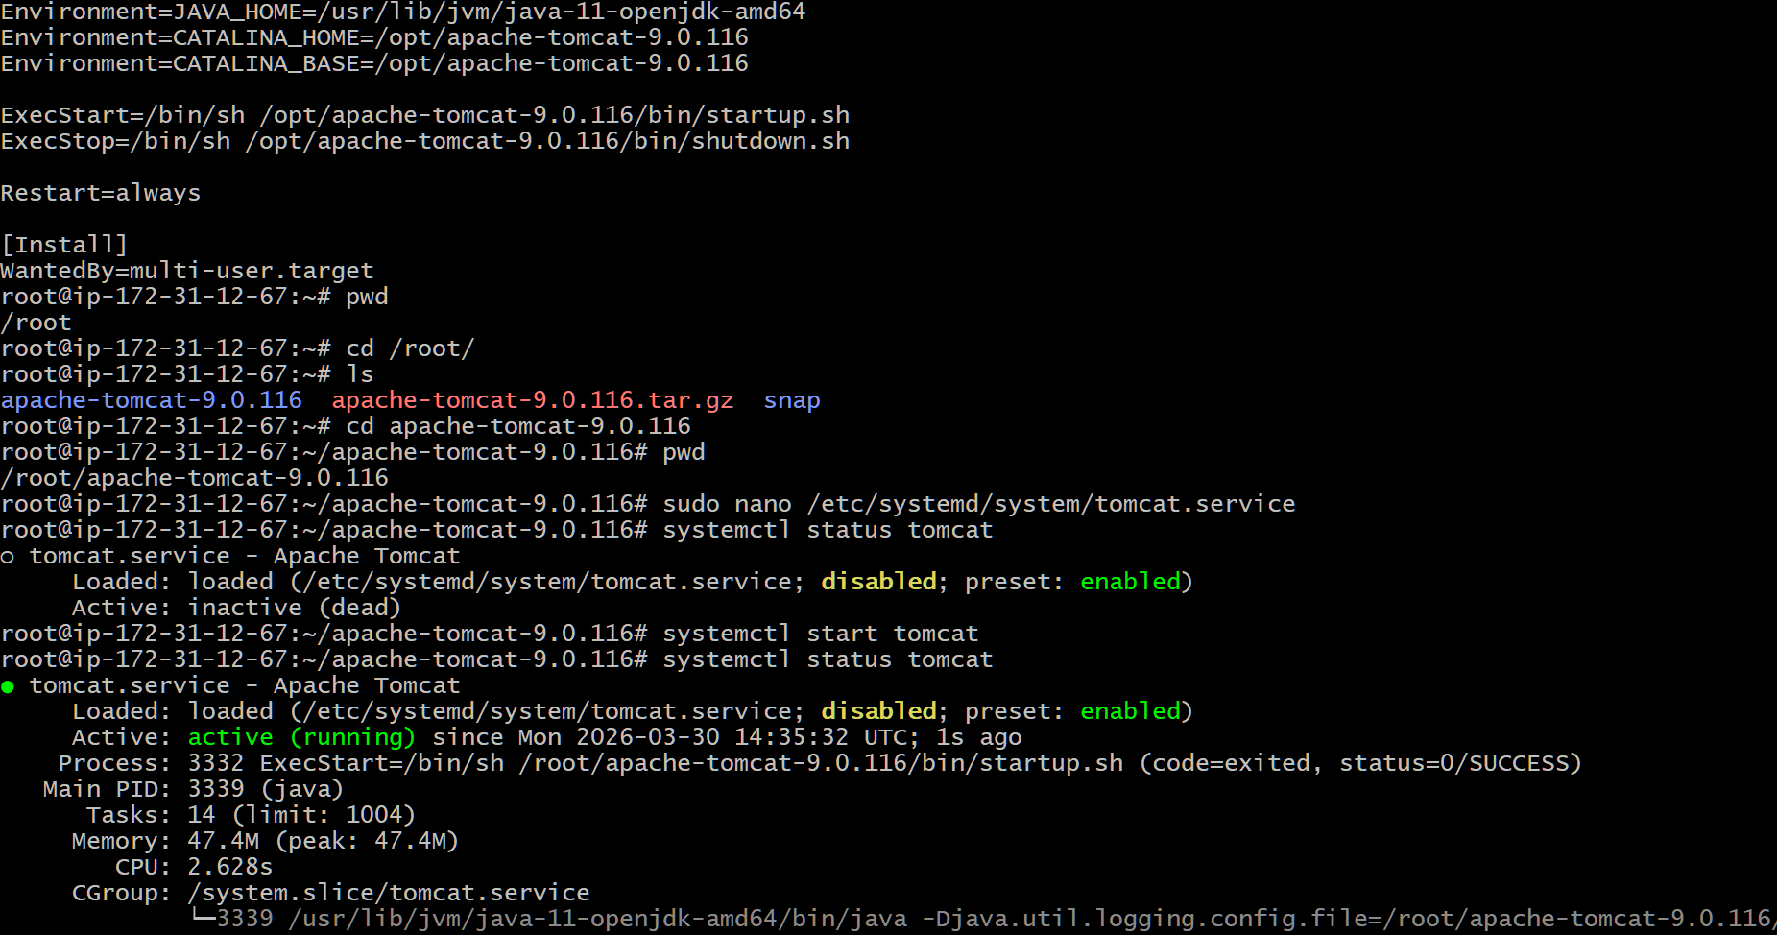

30) Print specific columns from a delimited file.
Specific columns from a file were printed using the awk command.
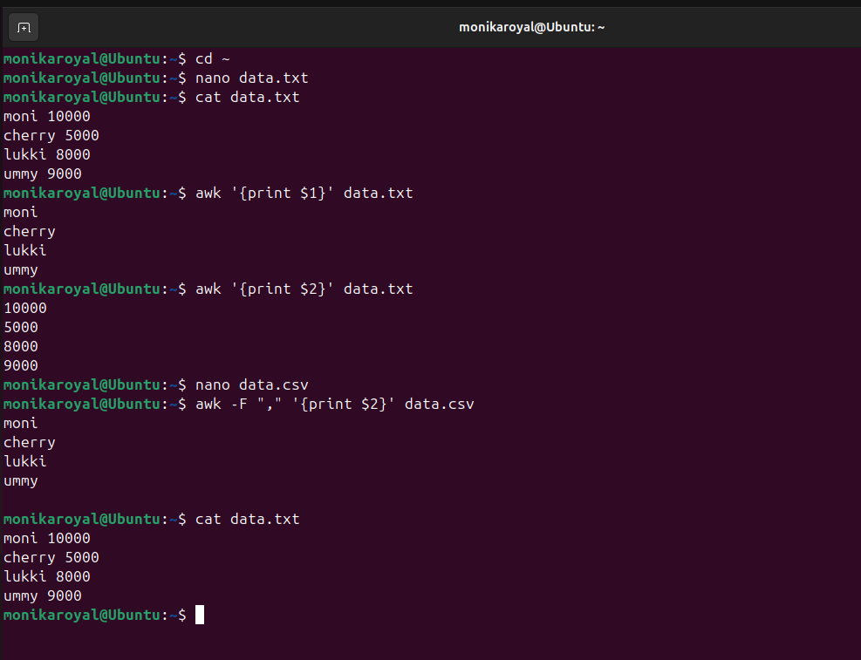

31) Filter and print lines based on a specific pattern or condition.
Lines were filtered based on a pattern using the grep command.
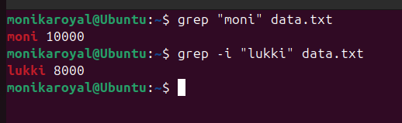

32) Calculate and print the average, sum, or other statistics of a column.
Column statistics like sum and average were calculated using awk.
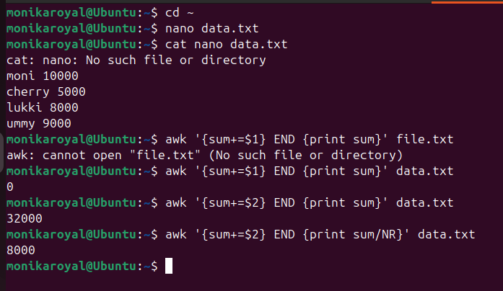

33) Perform string manipulation, such as extracting substrings or changing case.
String manipulation was performed using awk and cut.
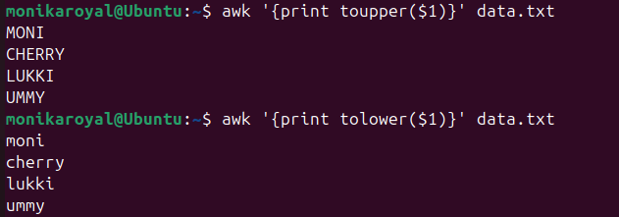

34) Count the occurrences of a specific pattern in a file.
Pattern occurrences were counted using grep -c.
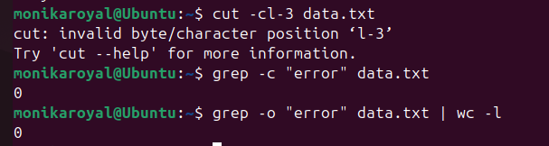
35) Sort lines based on a specific field or column.
Lines were sorted using the sort command.
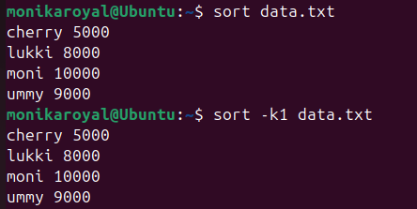
36) Merge multiple files based on a common field or column.
Multiple files were merged using the paste command.
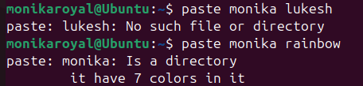

37) Substitute text in a file using search and replace.
Text was replaced using the sed command.
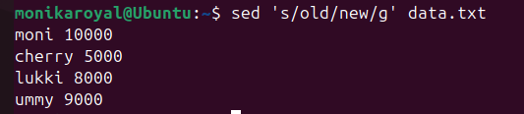

38) Delete specific lines based on a pattern or line number.
Specific lines were deleted using the sed command.
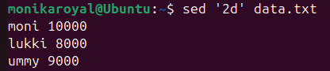

39) Append or insert text before or after a specific pattern or line.
Text was inserted before or after lines using the sed command.
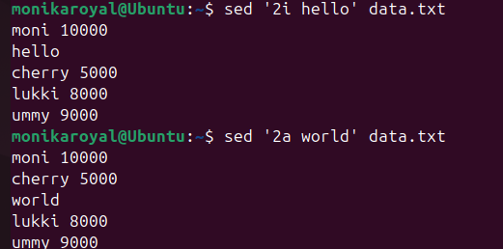

40) Print only specific lines from a file.
Specific lines were printed using the sed command.
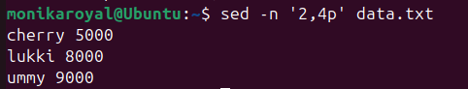

41) Copy file from linux to windows machine
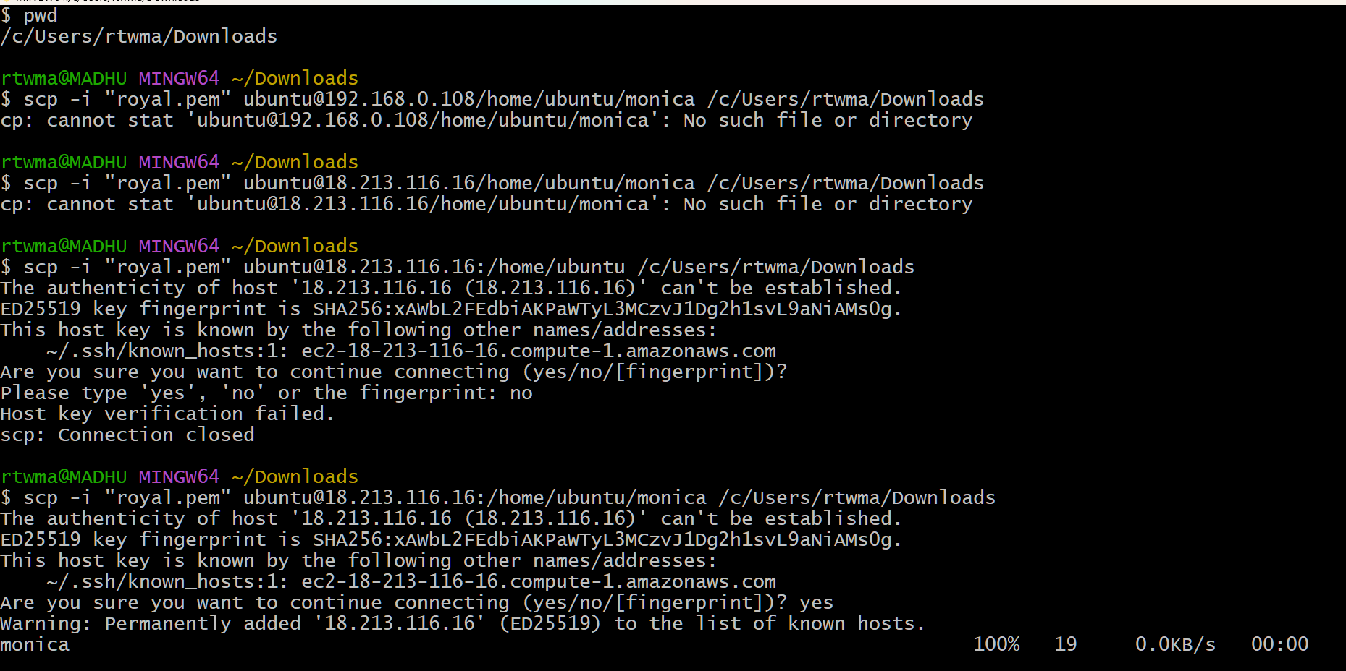

42) AWK and SED are used for data processing, filtering, text manipulation, and automation tasks in Linux.
1.SAdd text before a line
Sed’2i’data.txt



2.Print specific lines
Display selected lines
Sed -n’2p’data.txt


3.perforn calculations
Calculate sum,average,etc.
Awk’{sum+=$2}END {print sum}’data.txt



4.change text case uppercase and lowercase
Converting to get uppercase awk ‘{print toupper($1)}’ data.txt
Converting to get lowercase awk ‘{print tolower($1)}’ data.txt


5.perform calculations
Calculate sum/average,etc.
Awk’{sum+=$2}END {print sum}’data.txt


